# CS 255 Business Requirements Document Template

Complete this template by replacing the bracketed text with the relevant information.

This template lays out all the different sections that you need to complete for Project One. Each section has guiding questions to prompt your thinking. These questions are meant to guide your initial responses to each area. You are encouraged to go beyond these questions using what you have learned in your readings. You will need to continually reference the interview transcript as you work to make sure that you are addressing your client’s needs. There is no required length for the final document. Instead, the goal is to complete each section based on your client’s needs.

**Tip:** You should respond in a bulleted list for each section. This will make your thoughts easier to reference when you move into the design phase for Project Two. One starter bullet has been provided for you in each section, but you will need to add more.

## System Components and Design

### Purpose

*What is the purpose of this project? Who is the client and what do they want their system to be able to do?*

* DriverPass aims to address the problem of failed licensing tests by offering a platform with on-hand coaching and online study for DMV policies.
* The platform will host flexible packaging options and progress tracking to best assist users in successfully obtaining a driver’s license.

### System Background

*What does DriverPass want the system to do? What is the problem they want to fix? What are the different components needed for this system?*

* Through three packages, DriverPass offers solutions that most customers will find beneficial, as they can identify their needs and book the appropriate package.
* DriverPass will transparently display progress, available both on and offline to better assist users in understanding their progress and track usable metrics for the company.
* Reservations should be modifiable both from the website and via representatives that can be reached through telephone.
* Liam, the owner of DriverPass, has expressed that he wishes for the system to be compatible with Excel.

### Objectives and Goals

*What should this system be able to do when it is completed? What measurable tasks need to be included in the system design to achieve this?*

* Account creation
  + Should prompt user to input username, password, and email
  + Passwords should be encrypted using AES-256
  + Account access should follow principle of least privilege
  + Accounts should have account notes, and whenever an account is accessed, a note denoting who accessed the account should be written in automatically by the system
* Landing page
  + Host a picture of the student and their driving instructor in the bottom right corner
  + List any special needs the student has above the pictures
  + Display the account information such as address and name
  + Display course progress
  + Display driver notes
* Data services
  + Update data based on course progress
  + Download data in an excel compatible format
* Scheduling
  + Track availability of drivers
  + Change reservation times through the website and reserve the ability for employees to update this information

## Requirements

### Nonfunctional Requirements

*In this section, you will detail the different nonfunctional requirements for the DriverPass system. You will need to think about the different things that the system needs to function properly.*

#### Performance Requirements

*What environments (web-based, application, etc.) does this system need to run in? How fast should the system run? How often should the system be updated?*

* The system should run in a web-based application to ensure it runs on any platfrom with an approved browser
* Considerations need to be extended for mobile devices, as they will require different formatting from a desktop site
* Load times should be at two seconds or under to ensure Google ranks the website favorably and improve the user experience (*How to Measure and Optimize Page Load Time | DebugBear*, 2024)
* Provide feedback if the load time exceeds 4 seconds
* The site should be updated monthly as a part of regular maintenance, and as needed as issues arise.

#### Platform Constraints

*What platforms (Windows, Unix, etc.) should the system run on? Does the back end require any tools, such as a database, to support this application?*

* As a web-based application rather than run on any individual platform, the system should have minimum hardware requirements to be accessed through an appropriate browser.
  + Hardware requirements of 8 gb of ram, local storage is largely irrelevant for this use case
  + The system needs to run on Chrome, Firefox, Edge, and Safari
* Several databases are required for functionality
  + A database is required for login credentials for both employees and users
  + A database is required for user course stats and progress
  + A database is required for the courses offered and the content they provide
  + A database is required for scheduling purposes when attempting to schedule a session with an instructor
  + A database would be useful for relevant driving information and the courses they pertain to, to help keep the courses as up to date as possible
* Back end requires a web server to parse, process, and serve client requests

#### Accuracy and Precision

*How will you distinguish between different users?* *Is the input case-sensitive? When should the system inform the admin of a problem?*

* Employees and customers will have a separate login page
* Passwords are case sensitive
* Admins should be notified after 5 failed login attempts
* The user login page will display a forgot password hyperlink
* Forgot password hyperlink will prompt user for email input, which will send them an email containing a link to reset their password
* User accounts will host an account notes section visible to employees only to keep accurate records

#### Adaptability

*Can you make changes to the user (add/remove/modify) without changing code? How will the system adapt to platform updates? What type of access does the IT admin need?*

* Admin logins will host a toolset for their logins enabling them to view user information, delete accounts on request, and send a password reset link
* Users will have an option to delete their account in their account settings
* The above options will link to a SQL abstraction that performs the necessary action on the database so IT workers and users can update the databases without having to directly access it
* IT employees will have direct albeit monitored access to the databases
* Any maintenance windows will be communicated on the landing page of the website after logging in
* Maintenance windows will be between the hours of 12AM and 6AM to cause as little impact to user experience as possible

#### Security

*What is required for the user to log in? How can you secure the connection or the data exchange between the client and the server? What should happen to the account if there is a “brute force” hacking attempt? What happens if the user forgets their password?*

* Logins will be verified either by a device or network the user has used previously on multiple occasions or two factor authentication via an email code
* A message will be displayed when using two factor authentication not to share the code with anyone, including people claiming to be DriverPass employees
* Accounts will be locked after 15 failed login attempts in a row, requiring an administrator to unlock it
* Forgot password hyperlink will be displayed under the login prompt
* Forgot password hyperlink will lead to a page prompting a user to input their email, at which point the system will send a password reset link
* Standard HTTP TPS encryption will be utilized to ensure data and connection integrity

### Functional Requirements

*Using the information from the scenario, think about the different functions the system needs to provide. Each of your bullets should start with “The system shall . . .” For example, one functional requirement might be, “The system shall validate user credentials when logging in.”*

* The system shall validate user credentials when logging in
* The system shall utilize role-based access to ensure admins have access to necessary functions and users are prohibited from admin tools
* The system shall utilize the principle of least privilege to disallow users and admins from performing unauthorized functions
* The system shall allow users to create an account
* The system shall notify admins upon 5 failed login attempts
* The system shall display a message to users when using two factor authentication to not share their code with anyone, including people claiming to be DriverPass employees
* The system shall allow users to modify their account information
* The system shall allow users to reset their and only their password
* The system shall provide admins with a toolset for upkeeping and modifying user accounts
* The system shall allow employees to see the account notes on a user account
* The system shall automatically leave notes on a user account denoting the ID of the employee it was accessed by
* The system shall export user records as a csv file to be excel compatible
* The system shall meet a goal of load times under 2 seconds and inform users when load times exceed this metric
* The system shall use standard HTTP protocols to ensure a smooth and secure user experience
* The system shall be updated continuously to host current driving regulations
* The system shall display current packages and available times to book a session with a driving instructor
* The system shall allow a user to select and pay for a package
* The system shall allow users to schedule in person driving sessions with an instructor
* The system will inform users of the instructor's name, time slot chosen, and a description of the car they will use for their lesson
* The system shall allow learners to access coursework pertaining to driving regulations and procedures
* The system shall ensure payment information is secure
* The system shall ensure that payment for services rendered is paid to DriverPass
* The system shall display an account landing page including a driver photo, current course progression, and driver notes, driver notes are separate from internal account notes
* The system shall allow admins to modify instructor schedules and course enrollment as needed

### User Interface

*What are the needs of the interface? Who are the different users for this interface? What will each user need to be able to do through the interface? How will the user interact with the interface (mobile, browser, etc.)?*

* The interface needs to have a color scheme and font that is pleasing to look at
* Navigation buttons should be as concise as possible without sacrificing any of their description e.g. Settings should take the user to the settings page, a course button should take the user to the course specified, ect.
* The system will host two types of users, consumers and admins
* Consumers need to be able to
  + Access their account landing page which should contain
    - Name
    - Phone number
    - Email
    - Currently enrolled courses and progress
    - Driver photo
    - Driver notes
    - A navigation bar in the top right corner with the selections to
      * Sign out
      * View schedule
      * Go to settings which should
        + Have the ability for the user to update the account information
        + Modify their payment methods
        + Delete their account
        + Host an FAQ board
        + Host a contact us page offering a contact email and chat window
* Admins need to be able to
  + Access their account landing page which should contain
    - A search for user accounts
    - Access to the account notes (Separate from driver notes)
    - Modify the in-person schedule
    - Chat with users that request support
    - Access the company email

### Assumptions

*What things were not specifically addressed in your design above? What assumptions are you making in your design about the users or the technology they have?*

* Users are assumed to have basic computer knowledge and understand how to navigate a website
* Admins are assumed to understand the tools they have available
* Admins are assumed to act in good faith with their tools
* Sourcing driving instructors will not develop into an issue through the lifetime of DriverPass
* Users are assumed to engage with the coursework and show up on-time and prepared during their in-person lessons

### Limitations

*Any system you build will naturally have limitations. What limitations do you see in your system design? What limitations do you have as far as resources, time, budget, or technology?*

* The system requires an internet connection
* Resources must be spent to keep payment methods and payments secure, alongside royalties to any payment processing services
* The online app requires a certain amount of computing power
* DriverPass only has ten cars, customers will have limited availability for in-person lessons

### Gantt Chart

*Please include a screenshot of the GANTT chart that you created with Lucidchart. Be sure to check that it meets the plan described by the characters in the interview.*

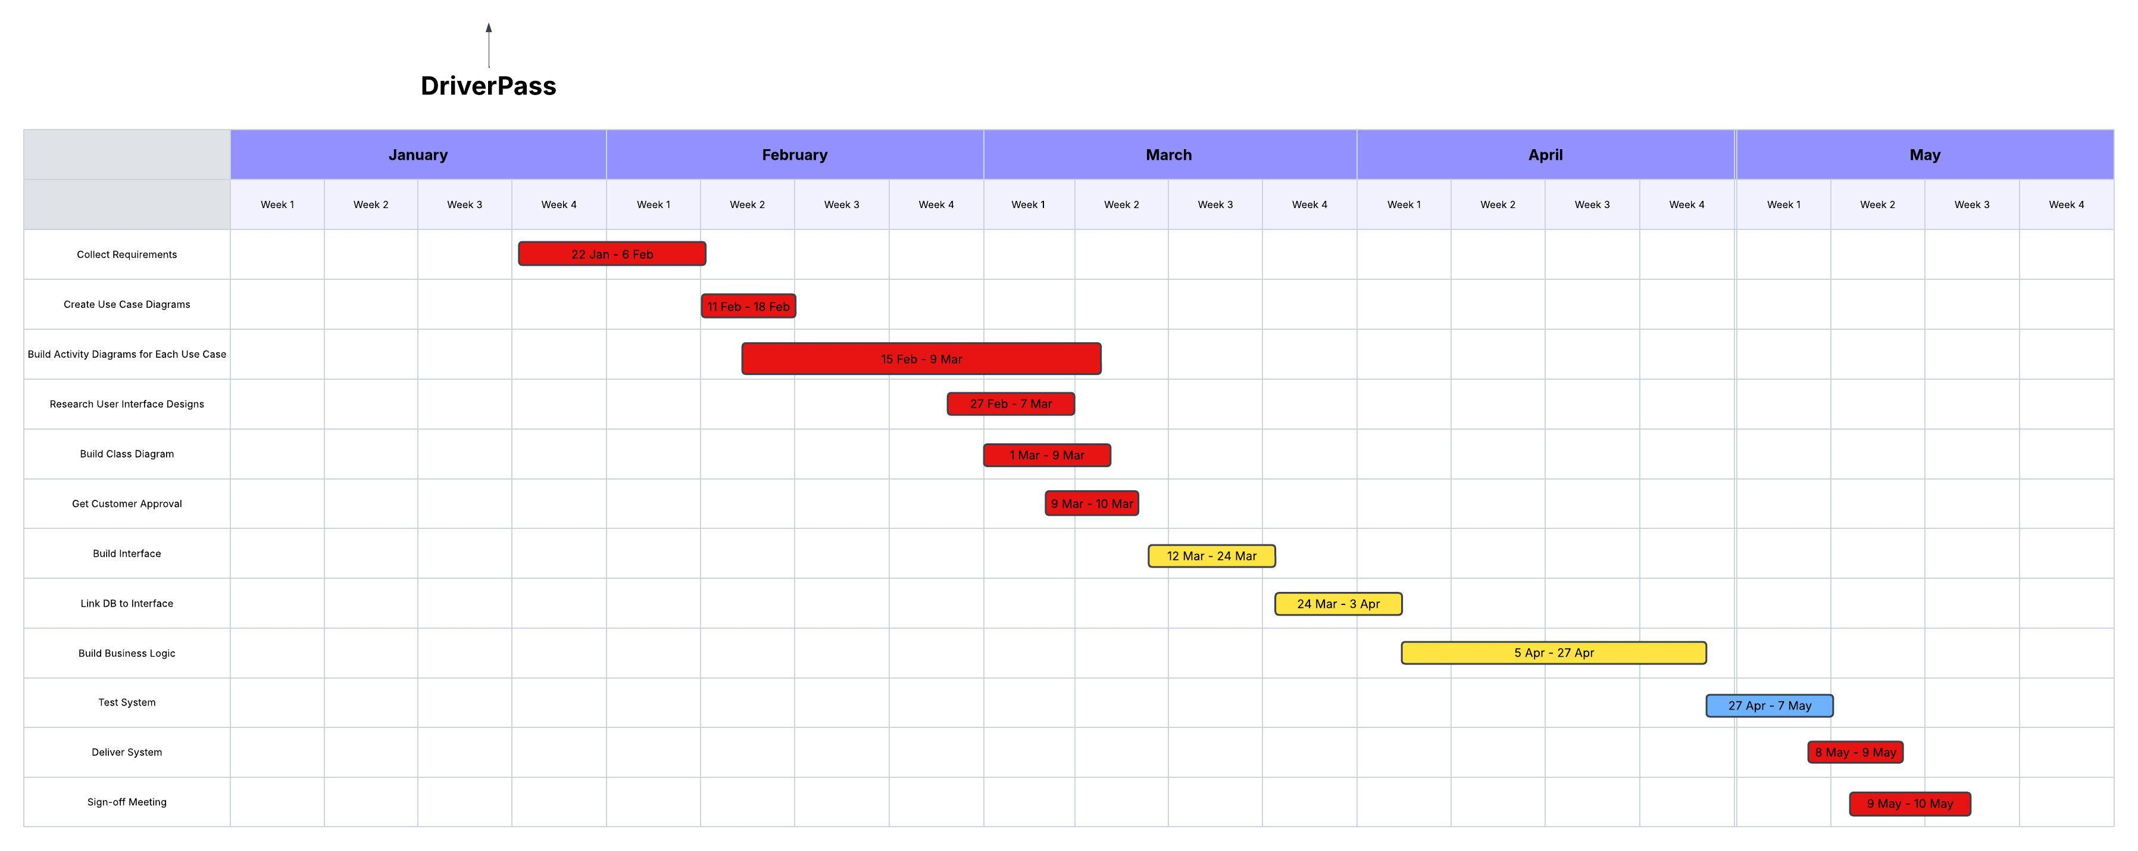

**References**

*How To Measure And Optimize Page Load Time | DebugBear*. (2024, October 15). Debugbear.com. <https://www.debugbear.com/docs/page-load-time>